How it works

Initial Screenshot

The app opens up and gives the user option of having Malayalam- English OR English-Malayalam

Based on that, the app responds.

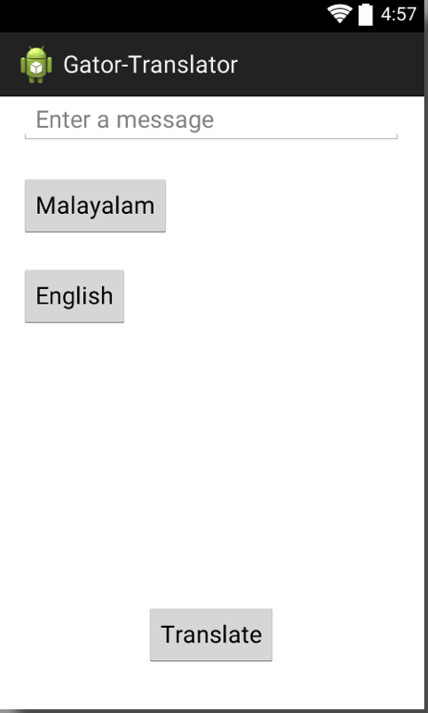

User enters the input and hits the translate button

Translated output.

